
2026
Expression of Interest
Irymple Library building

The opportunity to lease the Irymple Library building and deliver a Library Agency in the building.
Contents
Introduction 3
Background 3
Site – Location 4
Expression of Interest Scope 4
Lease Management 5
Key Service Deliverable 5
Key Selection Criteria and Weighting Scale 5
Your Organisation 6
Submissions 10
Submission Conditions 12

Introduction

The Mildura Rural City Council is inviting Expressions of Interest (EOI) from not-for-profit community organisations or groups who would like to lease the current Irymple Library building and could host a Library Agency.

Background

We envisage that this will be a place for people to meet, connect and participate in programs. Council is interested in considering any suggested use of the building, which would benefit the Irymple Community and support the delivery of strategic community outcomes to support a healthy, respectful and connected community as identified in the Council Plan 2025-2029.

These outcomes include:

- Everyone can reach their full potential
  - Everyone has opportunities to participate in the community
  - Everyone belongs
  - Our youngest residents have the best start in life

- People are physically, mentally and emotionally well
  - People are safe
  - We have diverse community and recreational services
  - We have a vibrant arts and culture community.

A small library agency could be included with support from the Council’s Libraries and Knowledge Hubs Branch.

This service model would allow customers to browse and loan from the Library Agency collection and to collect and return loans and reservations. The Library Agency could have the capacity to host our free library programs that will run from time to time.

The Library Agency model delivers significant improvements in the way the community will experience library services in the area. Libraries have shifted from being solely about a collection of items for loan. They are now closely aligned with the values and activities of community hubs, providing places for people to meet, connect and participate in programs.

Site – Location

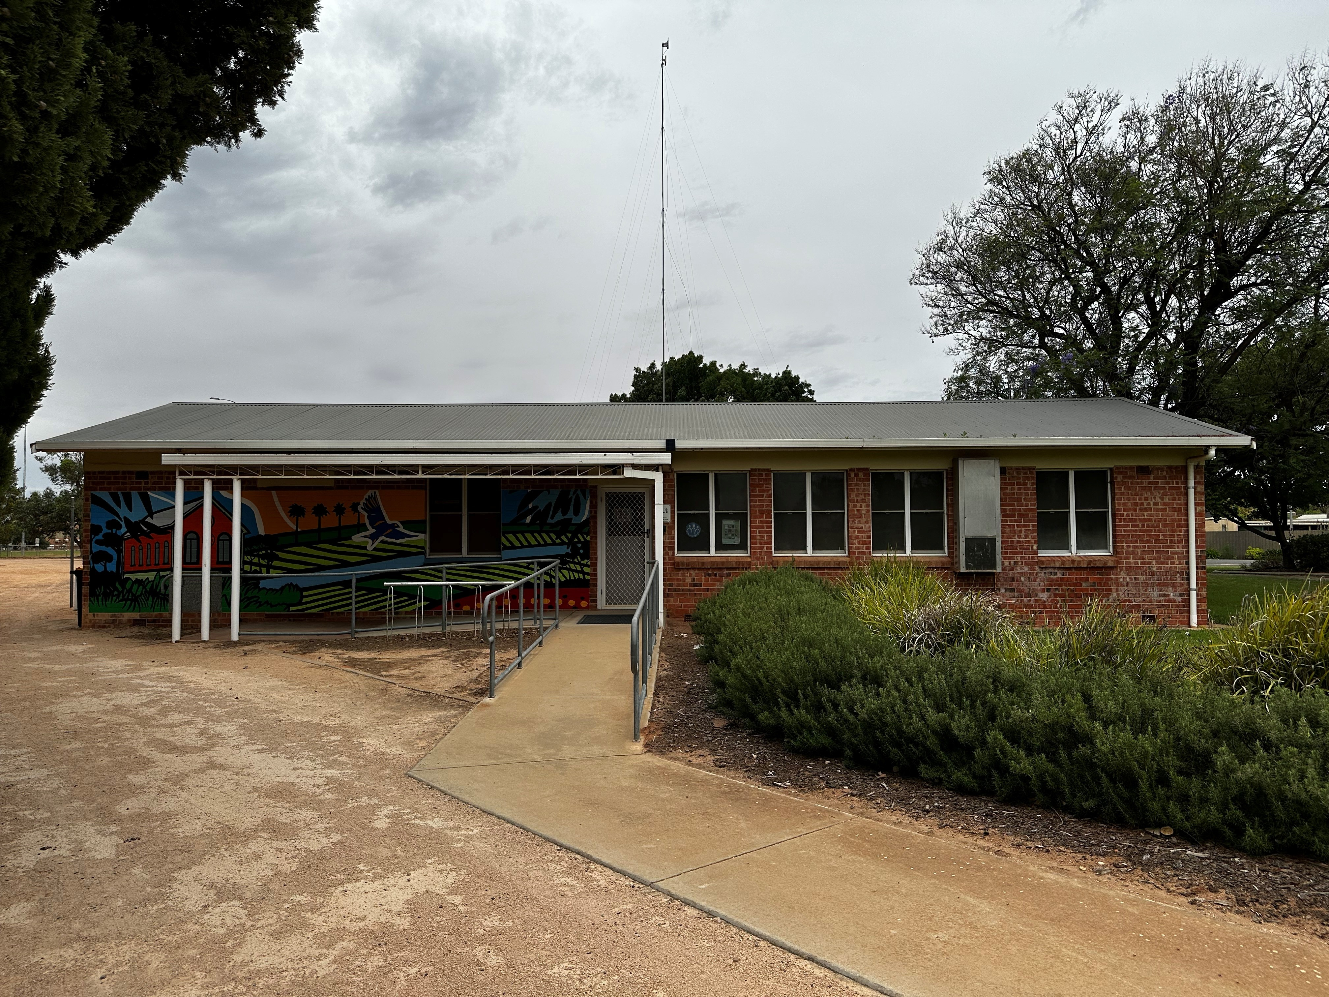

Expression of Interest Scope

The Expression of Interest asks questions in the following key areas:

- Organisation Contact Details – so we know who you are and how to communicate with you.

- Financial Information and Insurance - so we can jointly manage any insurance/liability risks.

- Your Organisation - so we know what you do, how your organisation is managed and what you are expecting of us.

- Your proposal for the use of the building - so we can understand your intended use and consider strategic outcomes for our community.

Lease Management

The successful Organisation will be required to enter into a Lease Agreement with Mildura Rural City Council for the use of the Irymple Library Building.

The Lease Agreement will state the roles and responsibilities of each party to the agreement. A copy of the draft lease template is available on request.

Council’s preferred lease term is an initial term of three (3) years, with two (2) further options to renew, each for an additional term of three (3) years.
The tenant is required to cover all usual outgoings including power, water and waste management fees.

The Council would provide, if required:

The Building
- Furniture that is currently in the Irymple Library
- Reception Desk
- Wi-Fi
- Library shelving

Library Agency
- Computer for Public use
- Computer for Catalogue access
- Library Management Software and Computer and receipt printer

Key Service Deliverable

The successful not-for-profit Organisation will demonstrate the capacity to
to utilise the current Irymple Library building and host a Library Agency.

Key Selection Criteria and Weighting Scale
A written proposal to Mildura Rural City Council is required addressing the following key selection criteria:

- Range of intended services/programs and alignment with Council Plan outcomes. | 50 %
- Inclusion of Library Agency | 40 %
- Planned hours of opening | 10 %

Your Organisation

Contact Details

Please provide your organisation details:

Organisation Name:
Incorporation Number:
Organisation Address:
Name of Contact Person:
Position Title:
Postal Address (if different to above):
Email:
Website:
Contact Telephone Number/s:

Financial Capacity and Insurance

Please give some approximate details about the financial capacity of your organisation (you can do this by providing a copy of your annual report if this is easier)

Annual income:__________________________

Annual expenses:_________________________

Do you have insurance?

Public liability Y or N (please circle)
Insurance company
Amount Insured For $ | Expiry date

Governance and Structure

How long has your organisation been operating?

What are the main objectives and actions of your organisation?

What is the Governance Structure? (you can attach a structure if you like)

Please give details of your organisation members.

Number of paid employees:

Number of volunteers:

Please provide a broad description of these roles:

Does your organisation publish an Annual Report?
If so please provide a copy with your EOI application

What are you proposing for the use of the Irymple Library building?

Who would be the target audience or beneficiaries of the planned activities?

Please include any value adding factors (e.g. innovations, environmental or social benefits) that your organisation might also contribute to the proposed leasing of the building?

Does your organisation already host or run any programs, presentations or training sessions? Please provide some details

Would you propose having a Library Agency in the Building? Please provide details including proposed operating hours or how you see this working.

What support would your organisation require from Mildura Rural City Council Libraries Team or other teams in relation to the use of the building?

Is there anything else you would like to tell us in regards to your proposal?

Submissions

Expressions of Interest Open | 14 September 2026
Expressions of interest close | 5pm on 16 October 2026
Shortlisting organisations/interviews | 19 October 2026
Organisation appointment | November 2026
Lease start date | TBC

Protection of Privacy

Your privacy, and the privacy of your organisation will be protected. The Mildura Rural City Council is gathering your information for the sole purpose of assessing Expression of Interest responses. It will be viewed by the Mildura Rural City Council evaluation panel solely for the Expression of Interest process and no other purpose. The Mildura Rural City Council will make every effort to protect your privacy.

Confidentiality

Your information and any information about your organisation or individuals submitted to the Mildura Rural City Council is confidential and is protected by the Mildura Rural City Council code of conduct. Mildura Rural City Council will ensure your information is kept confidential.

Expression of Interest Submissions Process

Information Session

Interested applicants are invited to attend an Information Session and view the facility at 5:00pm on 28 September at Irymple Library.

Alternatively, if you are unable to make this session, we will do our best to arrange an alternative time to discuss your proposal.

Please contact Rose Connell on 50188350 to register your attendance or to discuss your proposal.

This request for an Expression of Interest is the first stage in forming an agreement with Mildura Rural City Council to deliver community activities or services that could also contain a Library Agency.

A panel of representatives from Mildura Rural City Council will appraise the Expression of Interest responses. Mildura Rural City Council will then continue discussions with organisations with the aim of formalising an agreement through a lease.

The Expression of Interest response process, information pack and an online submission form are available at Council’s Your Say website at:
https://yoursay.mildura.vic.gov.au/irymplelibrary

Written submissions and/or enquiries can be directed to:

Rose Connell
Acting Manager Libraries & Knowledge Hubs
Mildura Rural City Council
E: rose.connell@mildura.vic.gov.au
P. 03 5018 8350
Mail – PO Box 105, Mildura, VIC, 3501

Please make sure you allow enough time for it to arrive by post (you might like to consider express post).

Submissions must include:
• Responses to all key selection criteria outlined above
• Relevant supporting documentation

Submission Conditions

Any proposal received will be reviewed by a panel of Council officers and recommendations made.

Council reserves its right to:
a) Seek clarification of or further information in connection with any submission.
b) Not proceed the expression of interest process.
c) Run a subsequent expression of interest process should the outcome of this process be unsuccessful.

Leasing:
Council will enter into a lease agreement with the successful applicant.

Compliance with conditions:
Parties responding to this document should note that the degree of compliance with the specified conditions will be an essential consideration in the process of evaluating submissions.

Insurance and workers compensation:
If deemed appropriate for the offering, the tenant must at its own expense, insure and keep insured for the duration of the agreement, the following policies of insurance:
- Public Liability Insurance for an amount not less than $10,000,000.
- Workers Compensation Insurance as required by law in respect of any person deemed to be an employee.
- Insurance for the fixtures, fittings and contents.
- A Certificate of Currency will be required prior to commencement.

Occupational Health and Safety:
The partner will be responsible for compliance with all requirements, including applicable regulations, of the relevant Occupational Health and Safety Act and any applicable Australian Standard.

